INF1103 Lab 6 Submission
1: Python files:
- inventory_manager.py ✅
- inventory.py ✅
- product.py ✅
2: Updated inventory.json file ✅
3: UML Class Diagram ✅
4: Git Log ✅
5: Docker container running successfully:
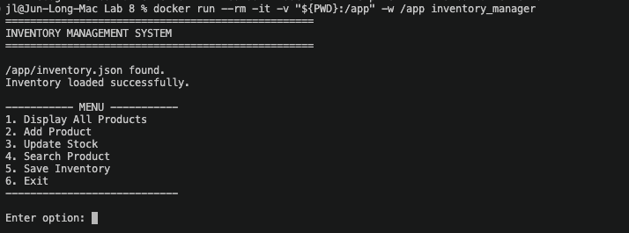
6: Screenshots of my program accepting input and producing the expected results:
(Already added before this to test)
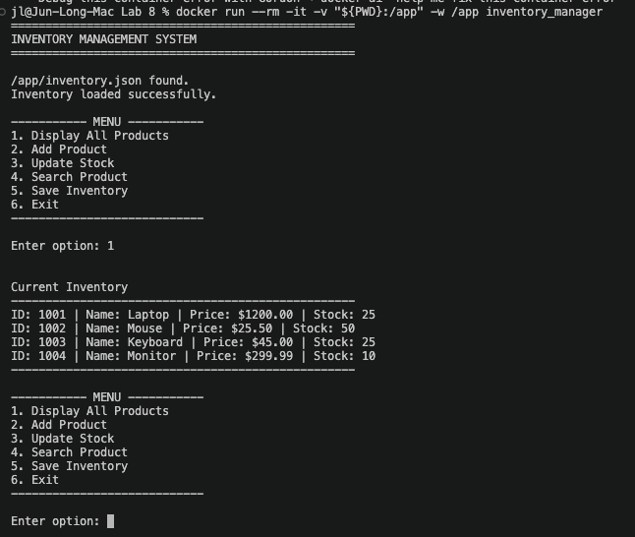

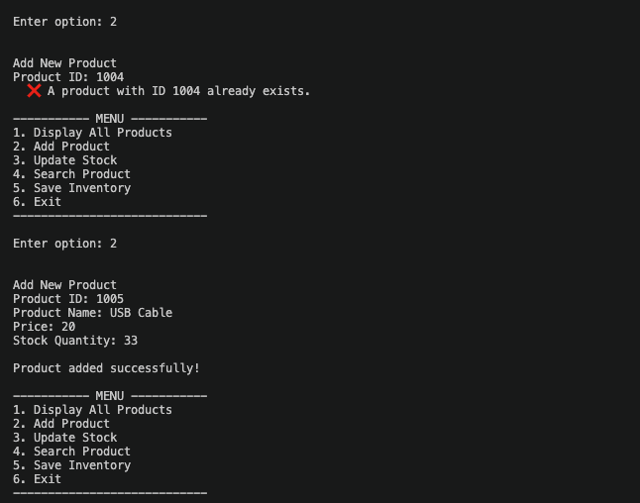
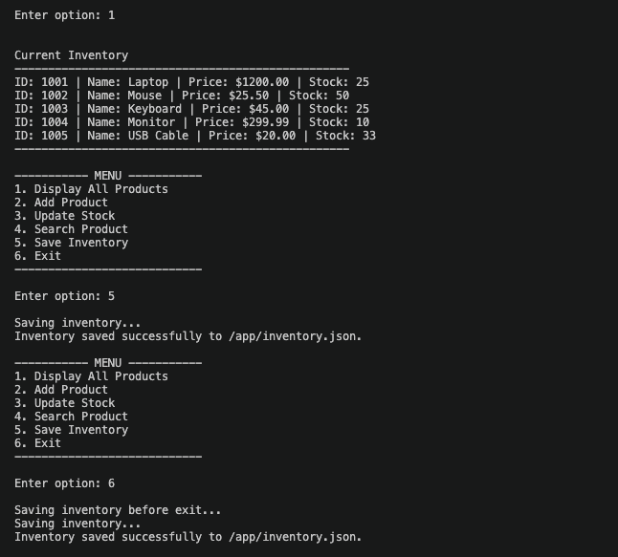

Reflection Questions:
1. What is the difference between a class and an object?
A class is the blueprint, and an object is a specific thing built from it. Product is the class, while Product("P001", "Laptop", 1200.00, 15) is an object, and the Mouse is a different object with its own data.
2. Why is Product a suitable class for this system?
A product is one of the main nouns in the inventory system. It has its own data and its own behaviour, and the store has many products that all share the same structure, which is what a class is for.
3. What data belongs inside a Product object?
Its product ID, name, price and stock quantity.
4. Why should Product manage its own stock rather than the main program changing it directly?
If the main program could set the stock directly, nothing would stop bad values like negative stock. Going through update_stock() lets Product enforce its own rules in one place, and if the rules change, only Product needs editing.
5. What does encapsulation mean in your program?
The data is kept private (__stock, __name and so on) and outside code can only use the public methods like update_stock() and the getters. Inventory.get_all_products() also returns a copy of the list so outside code can’t alter the real one.
6. What is the responsibility of the Product class?
To represent and manage one product, meaning it stores its information, controls changes to its own stock and can display itself.
7. What is the responsibility of the Inventory class?
To manage a collection of Products, meaning it stores them, adds them, searches for them, updates stock through them and displays them all.
8. How does separating these responsibilities demonstrate SRP?
Each class has one reason to change. Product changes if the rules for a single product change, Inventory changes if the way the collection is managed changes, and main.py changes if the menu changes. For example, if you switched from JSON to a database, you would only touch the load and save functions.
9. What information does the main program need to know about a Product?
Only its public side, meaning the constructor arguments (ID, name, price, stock) and the public methods such as the getters, update_stock() and display_information().
10. What information about the internal implementation of Product does the main program not need to know?
It doesn’t need to know that the attributes are stored as private __ variables, how update_stock() validates the quantity, or how to_dict() builds the dictionary. Those details can change without breaking main.py, as long as the public methods stay the same.

